CALENDAR OF AVIATION EVENTS
JUNE 2026 MAINE/NH
June 6
Pilot’s Forum
An informative and open aviation discussion
1st Saturday of every month (8-10AM)
Knox County Flying Club (KRKD)
372 Dublin Rd-Owls Head, ME
doug@kahnmail.com
June 20
Young Eagles Day
Pittsfield Municipal Airport (2B7)
EAA 736 (9AM-2PM)
Free airplane rides for kids ages 8-17
In conjunction with the CAF Wings of Freedom event
Jason.EAA736@gmail.com
www.facebook.com/EAA736
June 20
Commemorative Air Force (CAF) Wings of Freedom
Thompson Memorial Field (ME62)
128 Powers Rd-Pittsfield, ME
ac@andrewconstantine.net
June 20
Wings & Wheels Community Day
(11AM-4PM) Eastport Municipal Airport (KEPM)
Vintage/Classic Cars & Airplanes
Food Trucks-Airplane Rides-Live Music
www.EPMCommunityDay.info
June 20
Coffee & Donuts Fly-In
Limington-Harmon Airport (63B)
*Rain-date June 27
kyle@aerostateusa.com
June 20 Limington-Harmon EAA 141 Monthly meeting 9AM All Welcome!
downeast141@gmail.com
June 20
New Hampshire Seaplane Fly-In
2nd Annual Ayers Lake Campground Fly-In
Barrington, NH (10am-2pm)
BBQ-Bring something to share.
chiefpilot.nhpa@gmail.com
June 27
Knox County Flying Club Pancake Breakfast
Knox County Airport-(RKD) 8-10AM-$8
Last Saturday of month thru September
KCFC Club house east side of runway 31/13
bnbickford@gmail.com

June 6
Cruise Maine Car Show-Cruising for a Cure
Maine Children’s Cancer Program (MCCP)
Waterville Regional Airport (WVL)
10AM-2PM (rain or shine)-Food and Prizes
sisaac@newdimensionfcu.com
June 6
New Hampshire Seaplane Fly-IN
(10AM-2PM) Northeast Pond (Milton Three Ponds)
West Lebanon, ME/Milton, NH
$4 beach access for drive in’s-pilots are free
chiefpilot.nhpa@gmail.com
June 7
Coffee with Controllers
1st Sunday of every month-MacJets (PWM) 9-11AM
An old fashion meet-n-greet and great conversations
Fly-In or Drive (ramp fee waived w/ purchase of 12+ gal of fuel)
pwmcwc@gmail.com
*(Note no CwC in July due to holiday weekend)
June 11
Portland Pilot Lounge
2nd Thursday of each month (6-8PM)
Batson River Brewing-82 Hanover St-Portland
An evening of hangar flying
Call or Text Mark 207-230-4818
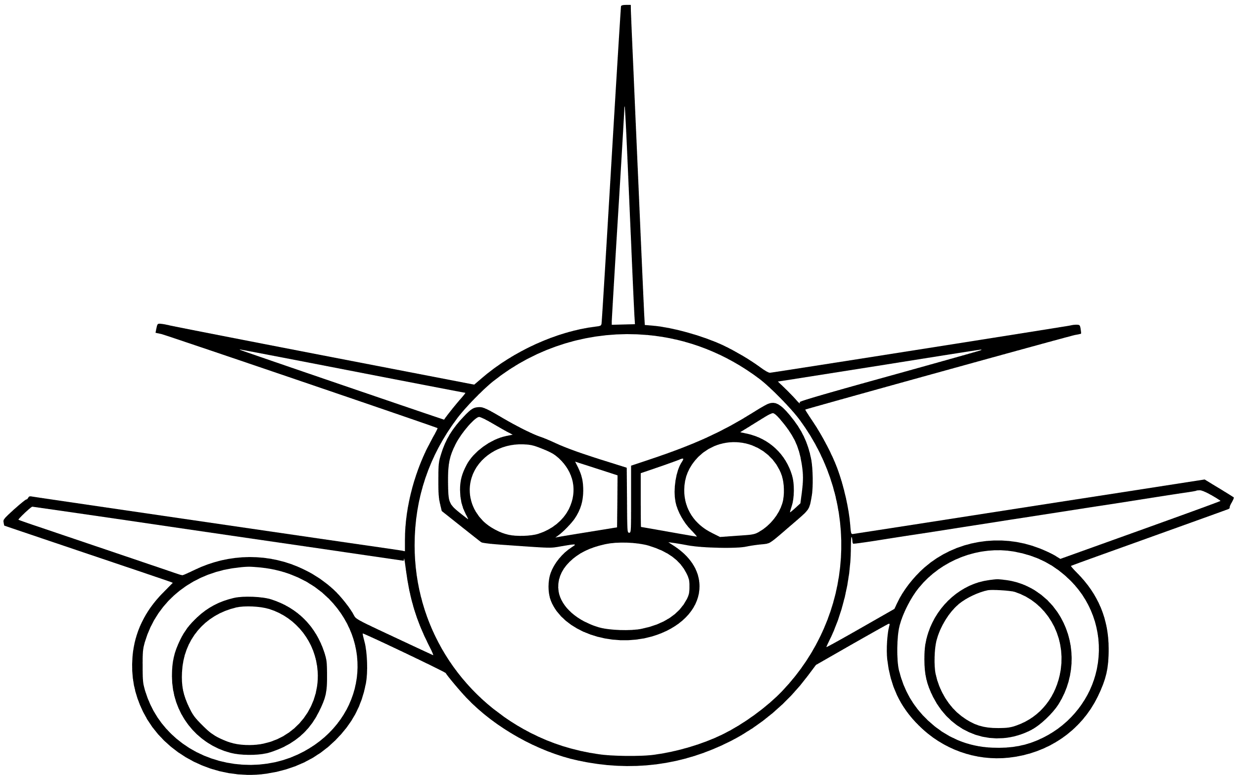
June 13
Tailwinds & Tailpipes and Young Eagles Rally
(EAA 87) Auburn-Lewiston Municipal Airport (KLEW)
Coffee & Donuts (8-Noon)-Car Show & YE Flights (9AM-1PM)
(Rain date for YE Flights and C&D-Sunday, June 14)
Food Trucks-Static Aircraft and Public Safety Displays
Upcoming July events
July 12
2nd Annual Spurwink Farm Field International Fly-In
Pancake Breakfast (8-11:30AM) Cape Elizabeth, ME
July 11-12
Great State of Maine Airshow
Featuring the US Navy Blue Angels
Brunswick Executive Airport (KBXM)

June 18
Volunteer Social
Owls Head Transportation Museum
(KRKD) (11AM-2PM)
Calling all volunteers…
past, present, and future!
Learn how to get involved at OHTM!
www.owlshead.org
Maine Pilots Association-Maine Aeronautics Association

